Q-1 Historical return

An invested in the share of TMH corporation at a price of 300 Rs per share. He purchased 200 shares. After one year he sells these shares at a price of 360 per share and also received the dividend of 10 Rs per share. Find out the total return earned by A.

Q-2 Historical return and Average Annual return

X purchased the share in 2000 at 52 Rs. Calculate return in below condition.

1. Total holding period return If x sells the share in the end of 2006.
2. Average annual return

|  |  |  |
| --- | --- | --- |
| Year | Dividend | Year End Price |
| 2001 | 1.95 | 58 |
| 2002 | 2.02 | 71 |
| 2003 | 2.13 | 63 |
| 2004 | 2.28 | 75 |
| 2005 | 2.5 | 84 |
| 2006 | 2.72 | 92 |

Q-3 Measuring Historical Risk

Mohan purchased the share of X Ltd in 2001 at a price of 180 Rs per share. Following historical closing prices and the dividend data is provided for X ltd Share for last 10 years. Calculate the rate of return as well as the risk (Standard Deviation) on the share of X Ltd

|  |  |  |
| --- | --- | --- |
| **Year** | **Dividend** | **Closing Price** |
| 2002 | 5 | 200 |
| 2003 | 6 | 220 |
| 2004 | 6 | 240 |
| 2005 | 7 | 290 |
| 2006 | 7 | 270 |
| 2007 | 8 | 325 |
| 2008 | 8 | 240 |
| 2009 | 9 | 380 |
| 2010 | 9 | 380 |
| 2011 | 10 | 425 |

Q-4 Expected Risk and Return

“DJ” equity analyst firm has information about two companies, namely, Raj Co. and DK Co. During recessionary period, the stock of Raj Co gives better returns, while the stock of DK Co. performs better during the growth period, relative to the stocks of other companies. The current market price of the stocks of both the companies is Rs. 15 per stock. The firm further provides additional information about the rupee return (dividend plus price change) of both the stocks in the next year:

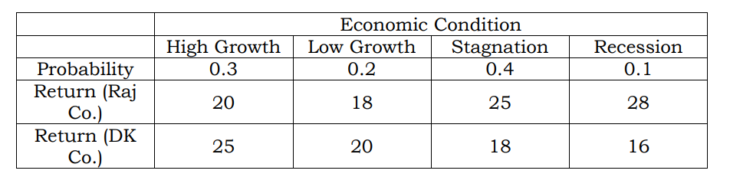

As an intern at the firm, you are required to prepare a note showing the calculation of expected return and standard deviation for the following cases:

1. Rs. 1200 in the equity stock of Raj Co.

2. Rs. 1200 in the equity stock of DK Co.

3. Rs. 600 in the equity stock of Raj Co. and Rs. 600 in the equity stock of DK Co.

4. Rs. 900 in the equity stock of Raj Co. and Rs. 300 in the equity stock of DK Co

Q-5 Beta Calculation

You are a student of an elective course on financial management. Recently, the course instructor discussed about the concept of beta. As a stock market enthusiast, you are interested in calculating beta of Golden Co.

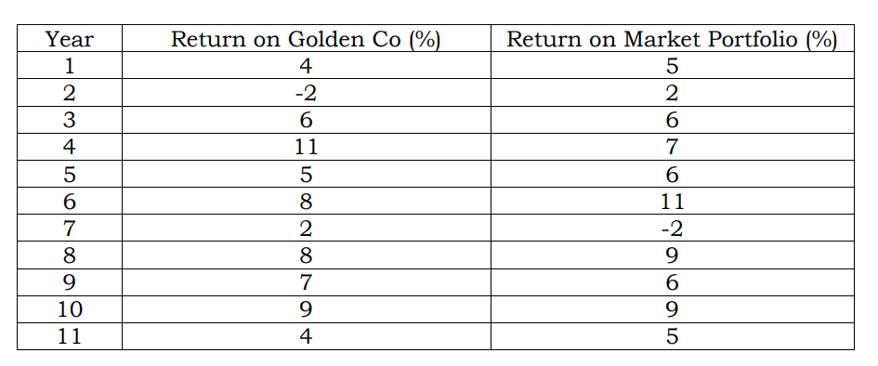

Q-6Portfolio Return

Consider ABC Ltd, an asset management company, has invested in 2 different assets along with their return earned last year. You are required to earn a portfolio return.

|  |  |  |
| --- | --- | --- |
| Security | Invested Amount | Return |
| A | 100000 | 10% |
| B | 50000 | 12% |

Q-7 Consider ABC Ltd, an asset management company, has invested in 2 different assets along with their return earned last year. You are required to calculated the expected return of portfolio if ABC has invested 100,000 in A and 200000 in B.

|  |  |  |  |
| --- | --- | --- | --- |
| Market Condition | Probability | Return (A) | Return (B) |
| Good | .3 | 22% | 6% |
| Average | .5 | 14% | 10% |
| Bad | .2 | 7% | 11% |

Q-8 Portfolio Risk

You are given the following two securities. Calculate the portfolio return and risk if an investor invests 20% in security A and 80% in security B.

|  |  |  |
| --- | --- | --- |
| Security | A | B |
| Expected return | 15% | 9% |
| SD | 5.3 | 2 |

Coefficient of Correlation Between A and B is -0.94.